**Levi's CMS SI Daily Report**

**Date: 2019/06/20**

**We have completed the network connection setting of CMS in Jiuguang Store. (0020019498 / SH SOGO)**

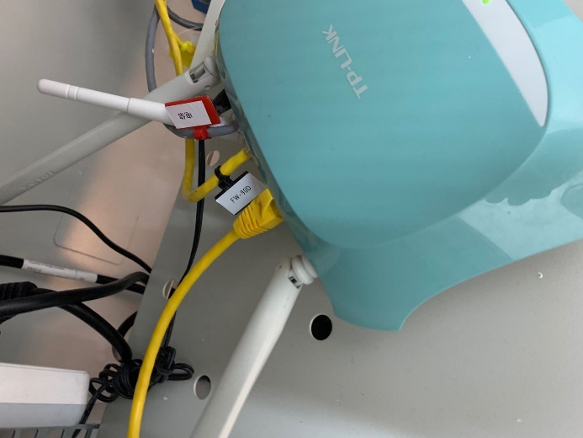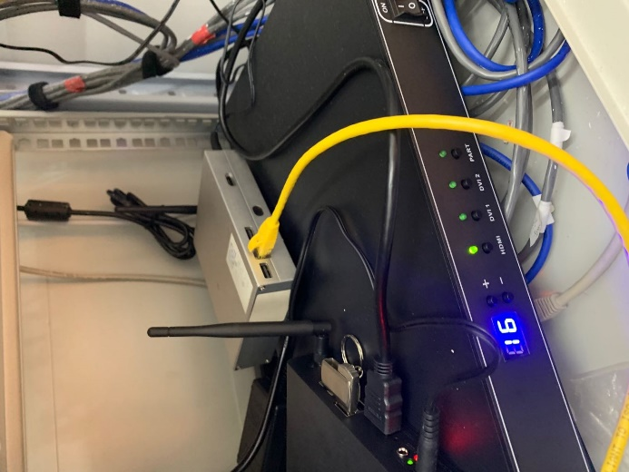**The following is the network connection SI result**

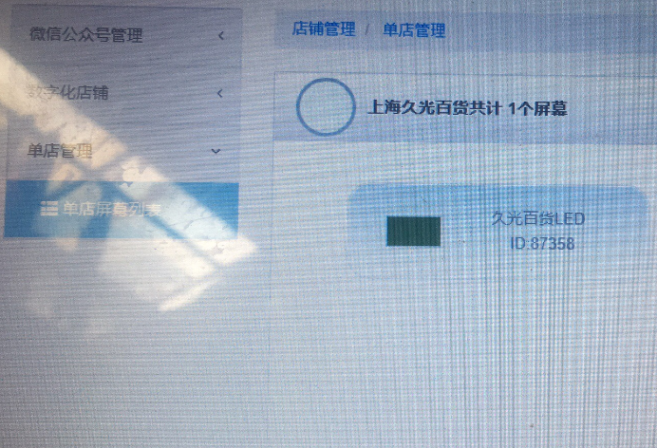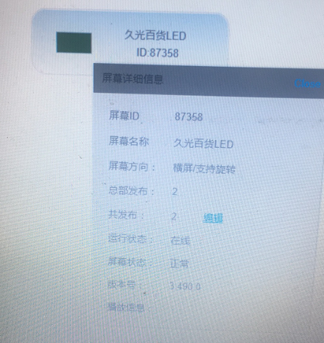**The following is the client-side state report**